Is your application an organized, tidy, and trimmed garden or a foggy, contaminated, overgrown swamp?
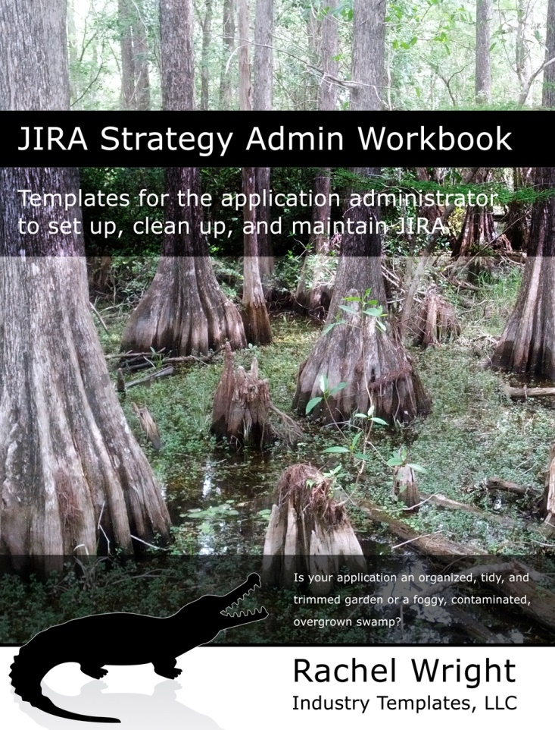
JIRA Strategy Admin Workbook
Templates for the application administrator to set up, clean up, and maintain JIRA
This book is different – it’s not documentation. It’s recommendations from years of cleaning up horrible JIRA configurations!
This book shows you:
- actions for a well-planned implementation,
- simple ways to streamline administration,
- how to audit and clean up the application,
- ways to maintain and extend JIRA,
- how to create repeatable procedures, and
- how to stay out of the “JIRA swamp”.
The JIRA Strategy Admin Workbook book contains:
- 151 recommendations and 32 real examples of problems to avoid
- 50 worksheets, plus additional templates, code snippets, and wording samples to help you establish and streamline vital processes
- Best practices for each administrative area, testing, and upgrades
- The top 10 mistakes I made as an administrator
- Content not available anywhere else
www.jirastrategy.com

JIRA Strategy Admin Workbook
Templates for the application administrator to set up, clean up, and maintain JIRA

Rachel Wright
Rachel Wright is an entrepreneur, process engineer, and Atlassian Certified JIRA Administrator.
She started using JIRA in 2011, became a JIRA administrator in 2013, and was certified in 2016.
She is the owner and founder of Industry Templates, LLC, which helps companies grow, get organized, and develop their processes.
Rachel also uses Atlassian tools in her personal life for accomplishing goals and tracking tasks. Her first book, the "JIRA Strategy Admin Workbook", was written in Confluence and progress was tracked in JIRA!

www.jirastrategy.com

